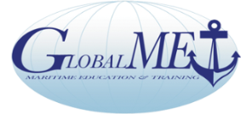

Global Maritime Education and Training Association

GlobalMET Limited: An Australian not-for-profit company - ACN 103 233 754 - established in 1996
AMC-UTAS Maritime Way, Newnham, Locked Bag 1397 Launceston Tas 7250
Chair: Capt Pradeep Chawla Anglo-Eastern Ship Management Hong Kong | Director - ExecSec: Capt Richard Teo (Australia)  Tel +61411725556 E: richsteo@gmail.com

Secretariat: Core Competency Training & Services 1070 10F Tower B1 Spaze iTech Park Gurgaon122002 India

Tel 91 124 45525 59 globalmet.secretariat@gmail.com, www.globalmet.org

The Global MET Network with NGO Observer Status at IMO

WITH COMPLIMENTS Date:

Returns for Venue and dates for AGM / EGM

Venue | Date & Day | Comments : Yes /No
Hong Kong | 2 March 2020 (Monday)
Singapore | 5 March 2020 (Thursday)
Singapore | 7 March 2020 (Saturday)

FROM:…………………………………………………………………………………….

NAME…………………………………………………………………………………….

DATE……………………………………………………………………………………..

FURTHER COMMENTS:

